Axiom Requisition Copy Service
447 North Canal Road, Lansing, Michigan 48917
517.886.5099 – 877.886.5090 toll free – 517.886.4116 facsimile

Saints Memorial Medical Center
Release of Information
1 Hospital Drive
Lowell, MA 01852

Re: Jessica Velmure
D.O.B.: 08/16/1989
SS#: XXX-XX-5219

Dear Custodian of Records - ext. 4326 or 4327:
By service of the attached subpoena, you are notified that the Keeper of Records of your company is requested to appear and testify on behalf of the defendant with respect to the above litigation. The deposition is scheduled for 10:00 a.m. on at this office and we ask that the individual who will appear on behalf of your office bring any and all documents in your company’s possession, custody or control that in any way relate to the items requested on the subpoena.
If you have any questions with respect to the deposition subpoena, or will have any difficulty in attending the scheduled time as set forth above, please contact our office so that we may resolve this matter prior to the aforementioned date.
In lieu of your appearance, you may mail the requested records prior to the aforementioned date to Axiom Requisition Copy Service, 447 North Canal Road, Lansing, MI 48917. If you have any questions, please contact customer service at (877) 886-5090.
In accordance with the requirements of the Health Insurance Portability and Accountability Act (“HIPAA”) Privacy Standards, please see the attached copy of my letter to Jessica Velmure’s attorney, Marc A. Diller, Esquire, regarding our subpoena to you seeking copies of certain documents held by you pertaining to Jessica Velmure. The letter specifies a ten day period in which AttorneyMarc A.Diller’s client may raise objections to the subpoena and requests that I be notified if such objections are being raised. The requisite ten-day period has passed and I have received no notice of any such objection.
Thank you in advance for your cooperation with respect to this matter.

Very truly yours
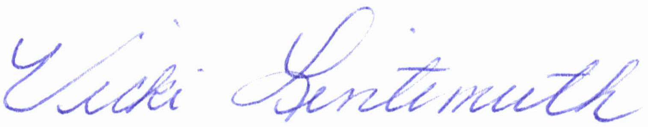
Vicki Lintemuth

Enclosures

Order No.: 01-18731-004

COMMONWEALTH OF MASSACHUSETTS

Subpoena Duces Tecum

PLEASE NOTE: You may mail your records to: John M. Horn, Esquire, c/o Axiom Requisition Copy Service, 447 North Canal Road, Lansing, MI 48917 prior to the deposition date. If you have any questions, please contact Customer Service at (877) 886-5090.

Worcester, ss:

To: Custodian of Records
Saints Memorial Medical Center
1 Hospital Drive
Lowell, MA 01852

Greetings:

You are hereby commanded, in the name of The Commonwealth of Massachusetts, to appear for a deposition at Horn & Lauretti, 225 Friend Street, Suite 204 , Boston, MA 02114, within and for the County of Middlesex on , at 10:00 a.m. in the forenoon, and from day to day thereafter, until the action hereinafter named is heard, to give evidence of what you know relating to an action of tort then and there to be heard and tried between:
Jessica Velmure , Plaintiff and
Davis Sims, Andrew Sims, and Mark Gibbons, Defendant
Middlesex Superior Court Court Civil Action No.: 09-1651

YOU ARE FURTHER REQUIRED TO BRING WITH YOU:
PLEASE REFER TO SCHEDULE "A" ATTACHED

Please note that if certified records are mailed to and received by Axiom Requisition Copy Service, 447 North Canal Road, Lansing, MI 48917, prior to the deposition date, no one needs to attend the deposition.

Hereof fail not, as you will answer your default under the pains and penalties in the law in that behalf made and provided.

Dated at ____________the ______day of ___________________.

Notary Public
My Commission Expires:

Order No. 01-18731-004

Custodian of Records
Saints Memorial Medical Center
RE: Jessica Velmure
Page Two

SCHEDULE “A”

The term "document" means the original and any copy, regardless of origin or location, of any written, recorded, transcribed, punched, taped, filmed or graphic matter, however produced or reproduced, including, but not limited to, any telegram, book, letter, memorandum, report, record, study, handwritten notes, working paper, calculation, analysis, test result, charge, paper, graph, index, tape, disc, data sheet, data processing card, diary, log or logbook, minutes of corporate meetings, minutes of municipal, state or federal governmental hearings, transcript, financial record, corporate record, cancelled check, photograph, contract, architectural or engineering plans and/or specifications, sketches, diagrams, schematics, regardless of point of origin of source, maps, correspondence, drawing, policy statement, rule, regulations, guide, newspaper and magazine and other publication and clipping consultants, summaries of reports of investigation or negotiations, and all other writings.

You are hereby required to produce at the time and place of the deposition the following documents:

- FROM 1995 TO PRESENT - MEDICAL RECORDS: And you are further required to bring with you CERTIFIED COPIES of any and all medical records, hospital records, office notes, consultations reports, prescription records, diagnostic test reports, lab tests, diagrams, charts, photographs, radiology reports and/or other documents within your possession, custody or control, relating to Jessica Velmure SSN: XXX-XX-5219, DOB: 08/16/1989.

Pertaining to:
Jessica Velmure
now or formerly of: 13 Porter Road , Chelmsford, MA 01824
DOB: 08/16/1989
SS#: XXX-XX-5219

This summons is not limited in time or scope.

Order No. 01-18731-004

